**How did Palestinian nationalism change in the 1960s and 1970s?**

**Lesson 10**

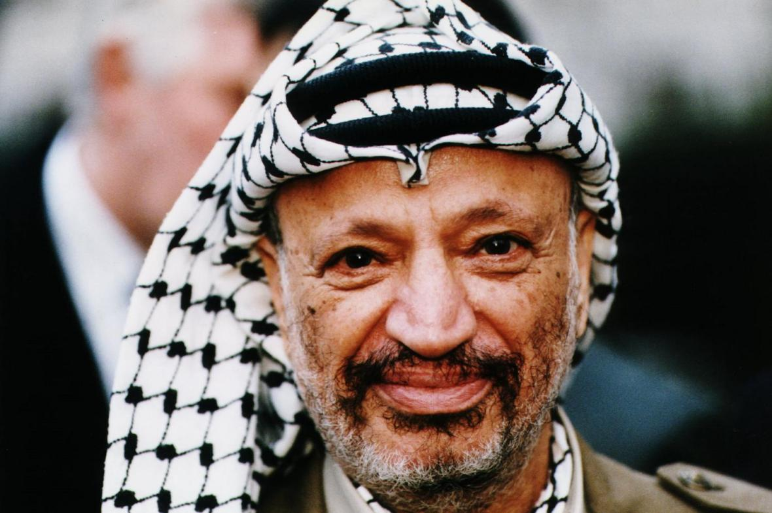

Yasser Arafat

**By the end of this lesson, you should be able to:**

Identify the impact of the June 1967 War on Palestinian nationalism

Describe the Palestinian national movement in the 1960s and 1970s

Explain the differences among Palestinian nationalists at this time

**Keywords**

Keffiyeh

Yasser Arafat

Fatah

Popular Front for the Liberation of Palestine (PFLP)

Palestine Liberation Organisation (PLO)

Munich Olympics Massacre, 1972

**Knowledge check!**

1)What is nationalism? What are some examples?

2)What is Palestinian nationalism?

3)Where did Palestinians live after the Nakba of 1948 and the Naksa of 1967?

**The keffiyeh**

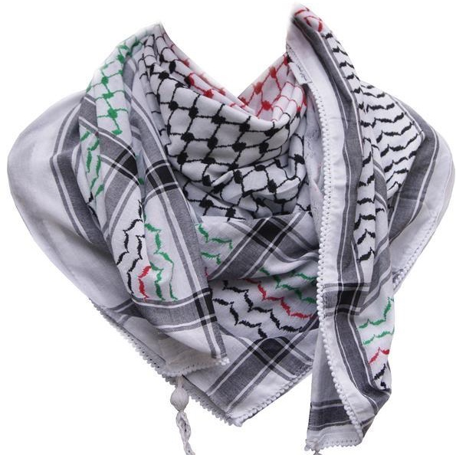

What comes to mind when you see the keffiyeh?

Violence?

Resistance to oppression?

Liberation?

The **keffiyeh** is a traditional Middle Eastern headdress which protects from the sun and sand. It became a symbol of Palestinian nationalism during the Arab Revolt of 1936-1939, a nationalist uprising by Palestinian Arabs against the British administration of the Palestine Mandate. The keffiyeh became very popular in the 1960s and was worn by **Yasser Arafat.** It is an important **symbol of Palestinian nationalism**

**Spot the keffiyehs!**

In May 2021, demonstrations for Palestine took place across the UK. 180,000 people gathered in London

How many keffiyehs can you spot in this photo?

**The impact of June 1967 on Palestinian nationalism**

Over six days in June 1967, Israel defeated Egypt, Jordan and Syria. By occupying the West Bank, Gaza, East Jerusalem, the Golan Heights and the Sinai Peninsula, the territory under Israel’s control quadrupled

Witnessing this defeat of their Arab neighbours, Palestinians realised that they needed to strengthen **their own national movement** against Israeli aggression. However, the Palestinians were geographically divided at this time, as we have already seen. This meant that the Palestinian nationalist movement was divided too

**Timeline activity**

Using the information below, create a brief timeline of the key events in Palestinian nationalism between 1959 and 1972

**Fatah**

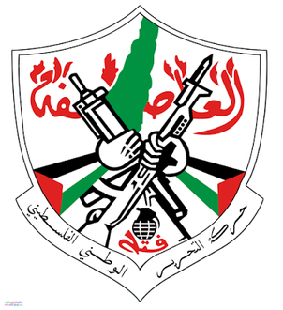

This movement started among Palestinians in refugee camps in Egyptian-controlled Gaza in the 1950s and was formally established during a series of meetings in Kuwait in 1959. Inspired by the Algerian liberation movement, the main founder was Yasser Arafat, alongside other Palestinians who had attended universities in Cairo and Damascus

Fatah quickly became very popular among Palestinian refugees in both refugee camps and urban centres such as Amman and Damascus. It was specifically about Palestinian nationalism (rather than Arab nationalism) and it was a secular movement (it advocated the separation of state and religion)

Fatah’s strategy was **armed struggle**, especially **guerrilla warfare** to **pressure Israel into leaving the occupied territories.** Its popularity was boosted by the Battle of Karameh of March 1968 . This was the first Palestinian victory over Israel on their own (without the help of other Arab states)

*Guerrilla warfare: when small groups use military tactics (eg. raids/ambushes) to fight a larger military (eg. Israel)*

**PFLP**

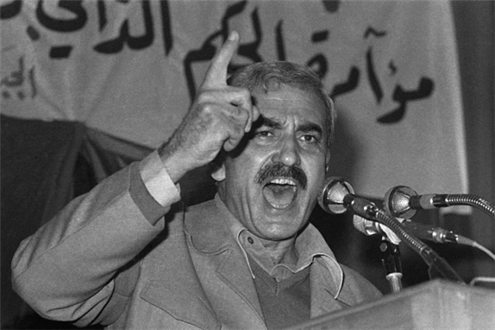

After Fatah, the Popular Front for the Liberation of Palestine (PFLP) was the next biggest Palestinian nationalist group in the 1960s and 1970s. Inspired by Latin American revolutionary ideology and Che Guevara, PFLP was founded by Palestinian Christian **George Habash** in 1967. Habash had previously founded the Arab Nationalist Movement in 1951, but in 1967 he turned his attention towards a more specifically Palestinian nationalism

Like Fatah, PFLP was a secular, non-religious group. Its strategy was **armed struggle**, particularly **attacks outside Israel to bring global attention to the Palestine crisis.** In 1969, PFLP hijacked three planes and blew them up (without their passengers) in the Jordanian desert. Again, in September 1970, PFLP hijacked four planes and blew three of them up (without their passengers) at Dawson’s Field in Jordan

**PLO**

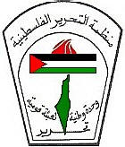

Although Fatah had been established in 1959, in the early 1960s there was still no recognised representative Palestinian body. To address this, Gamal Abdel Nasser of Egypt convened the first Arab summit in Cairo in 1964. The aim was to **establish a recognised representative Palestinian body**

It was difficult to organise this, given the geographic dispersal of Palestinians at this time. Eventually however, the **Palestine Liberation Organisation (PLO)** was established as a recognised representative body of the Palestinian people, with the motto ‘National Unity, Arab National Mobilisation, and Liberation’

The aim of the PLO was to establish a Palestinian state across the whole of Mandate Palestine. Its strategy was **armed struggle** to achieve the liberation of Palestine

Rather than thinking of the PLO as a rival to Fatah or PFLP, it’s best to think of the PLO as an **umbrella organisation of Palestinian nationalism**. Fatah joined the PLO in 1967, and has mostly been the dominant party in the PLO ever since

Since 1964, the PLO has been **widely recognised as representative of the Palestinian people**. It has had **observer status** at the UN since 1974, which means that it can participate in UN activities, but it cannot vote

**Activity**

Use this information to complete the table below on Palestinian nationalism in the 1960s and 1970s:

**Questions**

What was the difference between Fatah and PFLP?

Would you have supported either group if you were Palestinian in the 1960s and 1970s? Why?

**The PLO, Jordan and Black September**

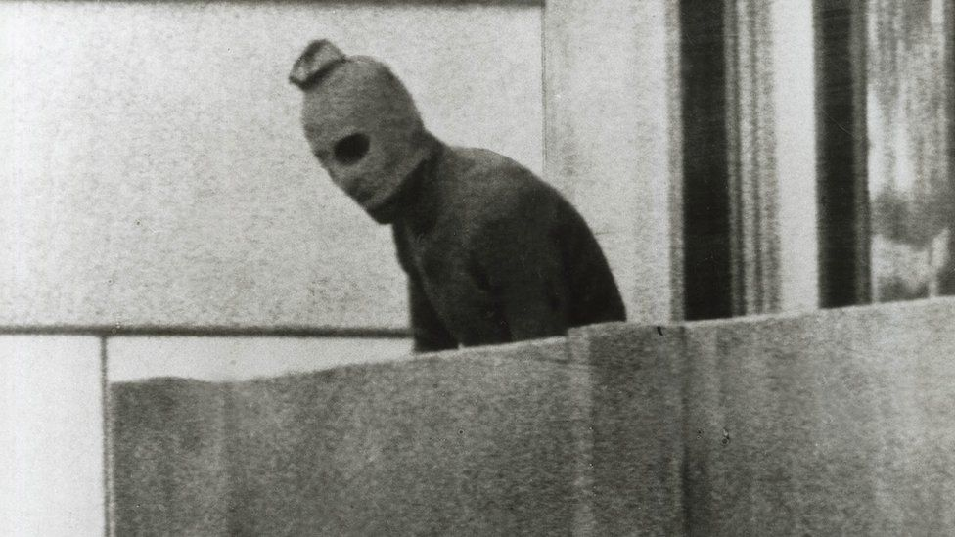

After the June 1967 War, the PLO and Fatah launched attacks on Israel from their bases in Jordan. This meant that when Israel retaliated, Jordan was affected. Not only this, but King Hussein of Jordan was concerned because half of the Jordanian population were Palestinian refugees and this threatened his leadership of the country

In 1970, after the Dawson’s Field attack, King Hussein **expelled the PLO from Jordan** and fighting ensued. This is known as Black September. Over 3000 Palestinians and 500 Jordanians lost their lives. As a result of this, the PLO had to move to **Lebanon**

Not long after this expulsion from Jordan, a group called **Black September** emerged. In 1971, this group assassinated the Jordanian Prime Minister. And in 1972, they massacred nine Israeli athletes at the Munich Olympics

**The Lebanon War of 1982**

Having moved to Lebanon in 1970, the PLO launched attacks from Lebanon into Israel. This meant that tensions only increased between Israel and Lebanon. After an assassination attempt by Palestinian nationalists on Shlomo Argov (Israel’s ambassador to the UK), **the IDF invaded south Lebanon on 6th June 1982.** The IDF then moved northwards, attacking Beirut, the capital. By August, Lebanese leaders had had enough: they **ordered the PLO and Palestinian fighters to leave.** The PLO leadership and many fighters now went to Tunisia, Syria and further afield

It was in this context that the **Sabra and Shatila massacres** occurred. Between 16th and 18th September 1982, Lebanese Christian militias entered the now unprotected refugee camps of Sabra and Shatila and massacred between 460 and 3,500 individuals, mostly Palestinians. The IDF did not intervene to stop the massacre

**Palestinian identity**

Palestinian identity was strengthened in many ways throughout the twentieth century, including through embroidery and poetry. These are extracts from **‘ID Card’** by Palestinian poet **Mahmoud Darwish** from 1964. Read the extracts and answer these questions:

*-What is the message of this poem?*

-*What feelings are being expressed? Why?*

ID Card, Mahmoud Darwish

*Write down:*

*I am an Arab.*

*My ID card number is 50,000.*

*XXX*

*Write down:*

*I am an Arab.*

*Hair coal-black,*

*Eyes brown,*

*My distinguishing feature:*

*On my head a*koufiyah*topped by the*igal,

*And my palms, rough as stone,*

*Scratch anyone who touches them.*

*My address:*

*An unarmed village—forgotten—*

*Whose streets are nameless,*

*And all its men are in the field and quarry.*

*Are you angry?*

*XXX*

*Write down:*

*I am an Arab*

*Robbed of my ancestors’ vineyards*

*And of the land cultivated*

*By me and all my children.*

*Nothing is left for us and my grandchildren*

*Except these rocks…*

*Will your government take them too, as reported?*

*Therefore,*

*Write at the top of page one:*

*I do not hate people,*

*I do not assault anyone,*

*But…if I get hungry,*

*I eat the flesh of my usurper.*

*Beware…beware…of my hunger,*

*And of my anger.*

**Check your knowledge!**

1) What was the impact of the June 1967 War on Palestinian nationalism?

2) What did the following groups want, and what was their strategy to achieve it?

-Fatah

-PFLP

-PLO